
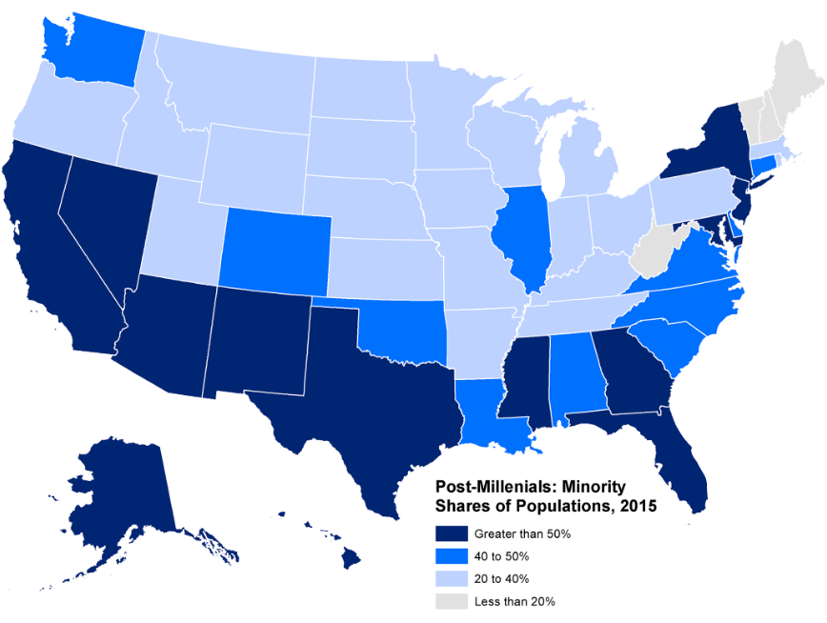
Immigrants in U.S schools
“More than 1 million immigrants arrive in the U.S. each year. Looking forward, immigrants and their descendants are projected to account for 88% U.S. population growth through 2065” [1]
[Cite your source here.]
1 million every year

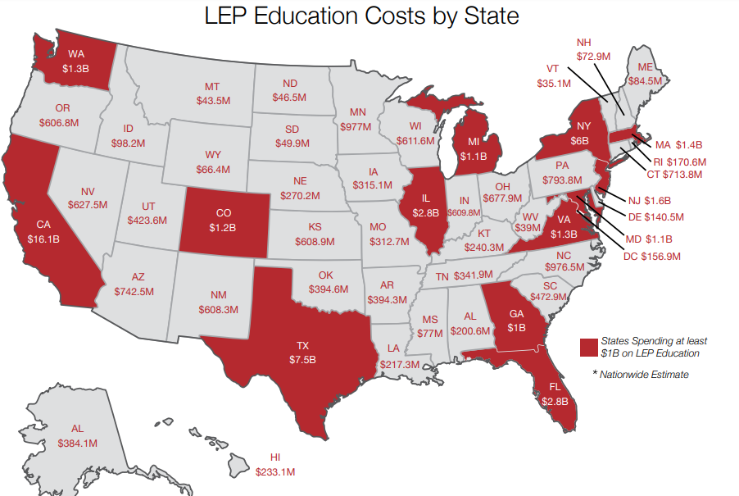
The cost of Immigration
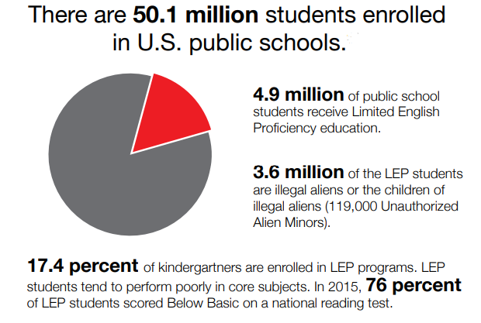

[2]

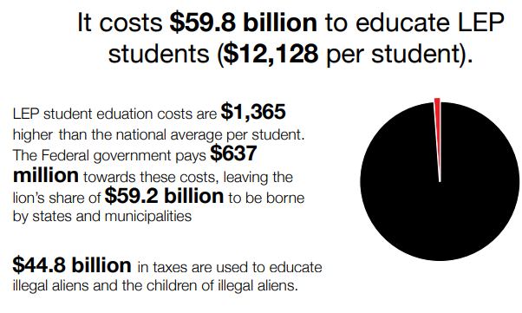
[2]



[2]

Immigrants in the Classroom

“Ratio of LEP certified to non lep certified teachers” (1:100) [2]

RaTIO of Students who are Ell’s [3]

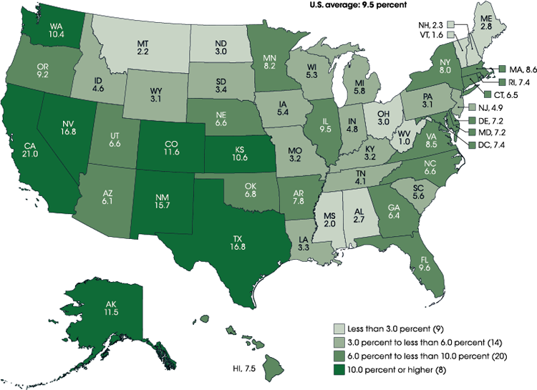


Do immigrants have the resources they need to succeed in school? In society?

Sources
- http://www.pewresearch.org/fact-tank/2018/11/30/key-findings-about-u-s-immigrants/

- https://fairus.org/sites/default/files/2017-08/FAIR-Education-Report-2016.pdf

- https://nces.ed.gov/programs/coe/indicator_cgf.asp

