Requirements:
- Hard copy and electronic copy of all materials
- Must use technology as a teaching tool
- Includes a digital product students create
- (Bonus) Choose strand and integrate it into the lesson somehow

Authors: Trevor + Pat
Lesson Overview:
Title: The Pythagorean Theorem
Essential Question(s):
- What does the pythagorean theorem state?
- What is the significance of this fact and how does it apply to your modern life?
Guiding Question(s):
- What does the pythagorean theorem inform you about?
- What are the different ways that you can use the pythagorean theorem?

Lesson Summary:
Subject Area(s): Math (algebra, geometry), Social Studies (history of pythagorean theorem).
Grade Level: 8th & 9th
INSTRUCTIONAL OBJECTIVES and ASSESSMENT (students demonstrate their learning):

AUDIENCE: 8th or 9th graders; able to reason abstractly but not without significant scaffolding; able to comprehend complex but not technical passages

BEHAVIOR: Students will be comfortable working with fractions, basic algebra, and fundamental mathematical notation (+,-,*,÷, _², √_ ); Students will collaborate in groups to solve more complex problems; Students demonstrate understanding via written work and conceptual discussion with their peers.

CONDITIONS: Students will view a class video via projector, Teacher will present the theory behind the PT and students will be given worksheets to color that demonstrates the geometry of the PT, Students will split into groups to work on seperate, more complicated problems and then present their findings to the rest of the class when finished.

DEGREE: Students should be able to converse about the content concepts in order to solve a problem together. Students will demonstrate understanding based on the clarity of explanations to the class and group members, work will be evaluated based on if the final answer is mathematically sound, and if the logic used to get to the answer is mathematically sound. Students will not only develop the ability to solve questions relating lengths, areas, and distances, but also develop skills to express their ideas to an audience.
Did you adapt this lesson based on another lesson? If so, give citation information for the original lesson:
- http://web.cs.ucla.edu/~klinger/dorene/math1.htm
Common Core State Standards (CCSS), or other Standards and Benchmarks: List at least one.

CCSS.MATH.CONTENT.8.G.B.6
Explain a proof of the Pythagorean Theorem and its converse.
CCSS.MATH.CONTENT.8.G.B.7
Apply the Pythagorean Theorem to determine unknown side lengths in right triangles in real-world and mathematical problems in two and three dimensions.
CCSS.MATH.CONTENT.8.G.B.8
Apply the Pythagorean Theorem to find the distance between two points in a coordinate system.
CCSS.MATH.CONTENT.8.G.A.4
Understand that a two-dimensional figure is similar to another if the second can be obtained from the first by a sequence of rotations, reflections, translations, and dilations; given two similar two-dimensional figures, describe a sequence that exhibits the similarity between them.

Instructional Approaches and Active Participation Strategies:
Connection(s) to the real world and/or students’ out-of-school lives and interests, or other ways to contextualize what students are learning:
- https://www.youtube.com/watch?v=eJ6ky97LaBc
- https://arxiv.org/pdf/0809.2379.pdf
Approximate time needed to conduct lesson (in minutes): 75 mins
30 minutes instructor-led time
15 minutes students completing worksheet (together or individual)
15 minutes group work
15 minutes presentation time
Step-by-step Procedure: Include detailed instructions and directions you will give students.
- The lesson will begin with Vihart’s video https://www.youtube.com/watch?v=X1E7I7_r3Cw and this will not only introduce the history and context for the PT but will also prompt students to think about ratios and relationships between numbers which is central to understanding the PT.
- Teacher will demonstrate proof of the PT. The students will be introduced to content-specific terms such as “leg” and “hypotenuse.” It is assumed that students will have background understanding of some geometry such as similarity as well as being familiar with mathematical operations such as squares and square roots. Teacher will assess the extent of this background knowledge through discussion and formative assessment. Students should know the geometric interpretation of a square root (the length of a side of a square with given area).
- https://www.youtube.com/watch?v=PJHtqMjrStk this is a video demonstrating a grade-appropriate way to approximate square roots although it is optional to show. Teacher will assess whether or not the topic of square roots is addressed before proceeding.
- Blackpenredpen’s video https://www.youtube.com/watch?v=itfXCKpmQPs will be shown in class to support teacher’s instruction. The proof shown in the video deals with some algebra (to differentiate algebra-heavy vs. geometry-heavy proofs) and the geometry of similar triangles. [30 minutes]
- Teacher should present the worksheet to students either on the promethean board to have them interact with it or pass copies out individually for students to color/cut-out etc. or a combination of both.
- At this point, students should be familiar enough with the PT to see example problems worked out by teacher. These problems should start out very simple and concrete and will act as both practice for the usage of the PT but also as scaffolding for the more abstract word problems students will work on later. [15 minutes]
- Teacher will now assess students understanding and execution of the PT via group work. Teacher will divide students in groups of no more than 5 and give each group a different word problem below. Three problems are attached here. These problems require a bit more critical thinking and evaluation in order to be solved while still requiring the PT. Students will collaborate with each other in order to work through the problems and teacher should wander the room and scaffold and assess students as they are working. [15 minutes]
- The lesson will conclude with students presenting their findings to the rest of the class via the Promethean board. [15 minutes]
Multimedia integration: Projector, Video, Promethean board.

https://www.youtube.com/watch?v=X1E7I7_r3Cw Funny Intro to Pythagoreas

https://www.youtube.com/watch?v=itfXCKpmQPs Algebra Proof

Attached document projected on promethean board as well as given to students to work with (for coloring or cutting out)

Differentiated instruction and Flexible Learning: Student’s will be guided through activities that demonstrate the proof of the the pythagorean theorem both algebraically and geometrically. Students will receive the proof orally (from instructor), visually (from videos), and kinesthetically (through activities).
Graphic organizer, concept map, or other scaffolds or support system(s): Videos, provided worksheet to help conceptualize the PT.
Assessment:
The rubric below provide guidelines
Formative Assessments:
- We will conduct several assessments through class-wide Question & Answer sessions. This will get the entire class to think collaboratively and share their input as to what we have gone over thus far in the lesson.

Summative:
- For this assessment we will be giving the learners a homework sheet where we can assess their understanding and they get more practice with the Pythagorean Theorem (Page 7).

Pecha Kucha Slide Show (20 slides, 20 seconds per slide):
- Slide show must follow the Pecha Kucha format: 20 slides, 20 seconds per slide)
- Slide show must automatically advance to the next slide after 20 seconds without clicking the mouse
- There must be sound, music, or narration to accompany the text and images on slides
- Strategies for differentiation must be explicitly described
- Assessment strategies must be explicitly described
- You must give an in-class presentation of your Pecha Kucha:

Info for stuff:
- http://web.cs.ucla.edu/~klinger/dorene/math1.htm
- https://link.springer.com/article/10.1057/jt.2009.16
- https://arxiv.org/pdf/0809.2379.pdf
- https://www.youtube.com/watch?v=eJ6ky97LaBc BBC
- https://www.youtube.com/watch?v=X1E7I7_r3Cw vihart
- Pythagorean theorem first stated in Babylon and Egypt.
- Used by archeologists in their field work.
- Used by Einstein to derive his Field Equations which where subsequently used to derive his theory of special relativity (The Field Equations apply the pythagorean theorem to rays of light in three dimensions).

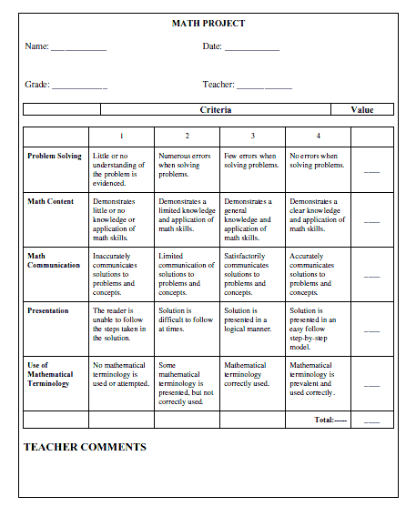

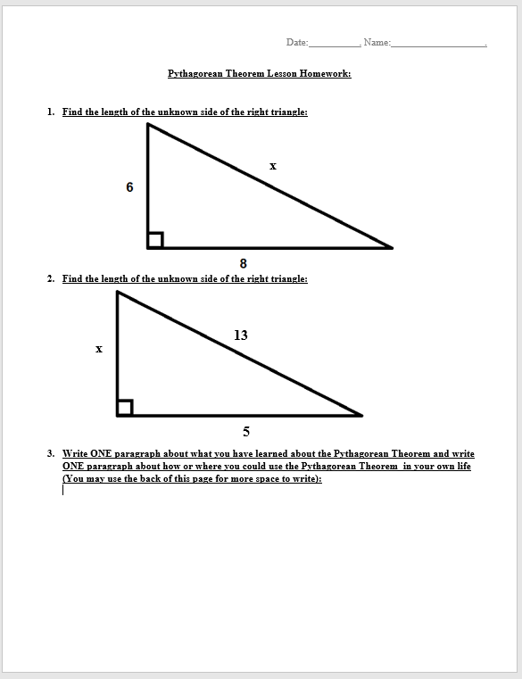

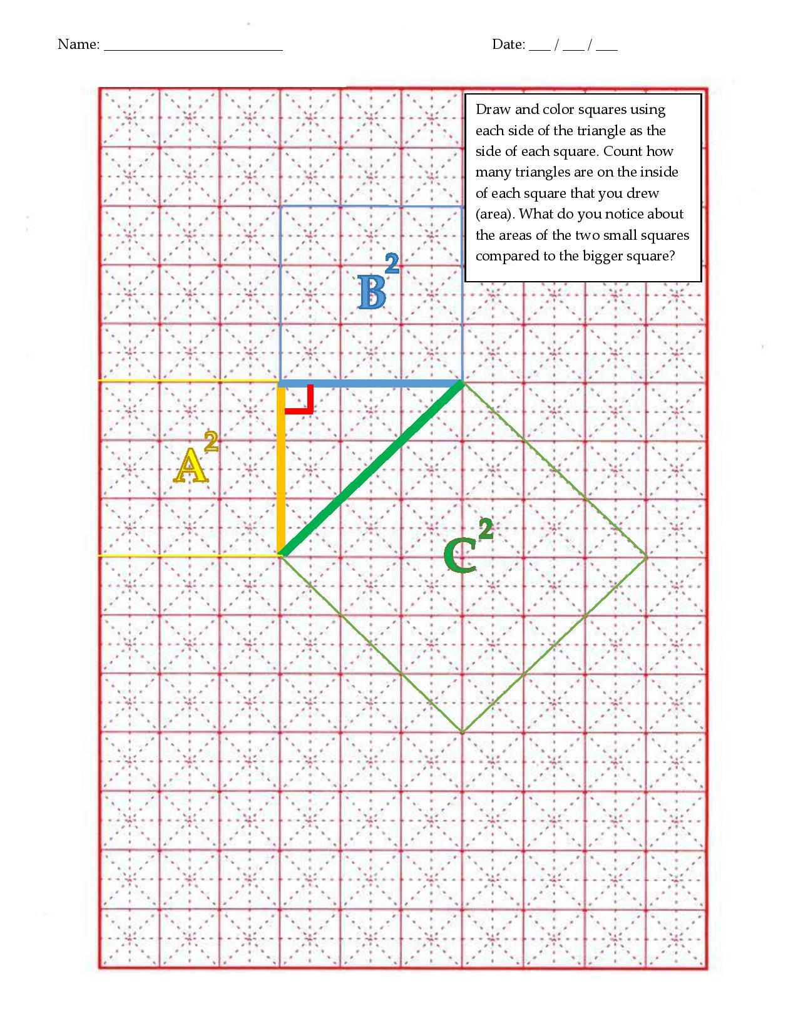

Group Problems:

The figure below shows the parcel of land on which Homer the rancher confines his hippos. The parcel will be enclosed by a fence, at a cost of $0.15 per centimeter. Find the total cost. [Hint: pay attention to what units your answer will be in]
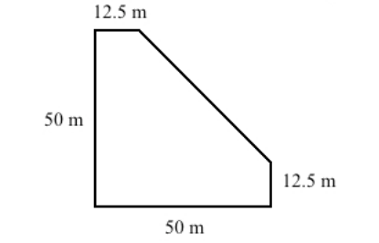

Plato and Aristotle are loitering on the street corner, when suddenly Socrates (to whom they owe money) shows up. Plato takes off skating eastward at a rate of 16 miles per hour, and Aristotle runs southward at a rate of 12 miles per hour. How far apart (direct distance) are Plato and Aristotle after 15 minutes? [Hint: use the fact that rate=distance/time]
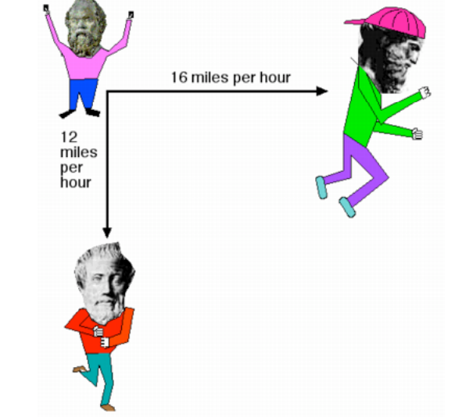

In the Old West, settlers made tents out of a piece of cloth thrown over a clothesline and then secured to the ground with stakes forming an isosceles triangle. How long would the cloth have to be so that the opening of the tent was 6 feet high and 8 feet wide? What would the area of the cloth be it the tent was 10 feet long? [Hint: draw a picture to represent the tent in two dimensions and then in three]

